# DECLARATION

I, **NDACYAYISENGA Fabrice** with Registration Number 18RP01492. I am a student :Integrated polytechnic Regional Center/ IPRC TUMBA, in Information and Communication Technology DEPARTMENT. Hereby declare that the work presented in this internship report carried out at **“Rwanda Broadcasting Agency**.**”** within 8 weeks that started On 20rd September 2021 and ended On 12th November 2021.

**The trainer**:

**Mr NDCYAYISENGA Fabrice**

Signature………………… Date ........./ ......./ .......

# ABSTRACT

It is in this regard that IPRC-TUMBA took decision of organizing Industrial Attachment for their students in order to help them to improve practical skills, experiences and also to know what is really done on field.

These 8 weeks Industrial Attachment period at Rwanda Broadcasting Agency, allowed me to strengthen my professional skills and interpersonal relationship in professional settings and I mastered what is done in our career.

The Industrial Attachment was carried out within Rwanda Broadcasting Agency.

The report outlines information about the organization and the responsibilities performed and experience gained from internship,

The report shows the benefits of the Industrial Attachment program. It helps the student to be fully aware of the real world practices before going on markets, to relate theoretical studies and to implement them on real job experience, to get outer exposure and to study the entire services provided by the organization which helps technical and professionalism students to become the experts.

# ACKNOWLEDGEMENT

This internship is the result of combined efforts from many people who, in a way or another, contributed to its completion and to whom we wish to express my heartfelt thanks.

I have a great pleasure for expressing thanks to my supervisor, whose insights and comments guided us towards the completion of this dissertation. I’m very grateful to her for having been available whenever i needed her help.

I’m also indebted to all Lectures at IPRC TUMBA especially Department of Information and Communication Technology for having advanced to my knowledge. I would like to express my sincere and special thanks to my Supervisor **Dukuze David.** Thank you all, may God reward you for your efforts.

# LIST OF ABBREVIATION

ICT: Information and Communication Technologies

PC:Personal Computer

CCU :Camera Control Unit.

IPRC :Integrated polytechnic Regional Center.

KC2 :Kigali channel2

OBVAN : Outside Broadcasting van.

RBA :Rwanda Broadcasting Agency.

RTV : Rwanda Televesion

**Contents**

Table of Contents

DECLARATION i

ABSTRACT ii

ACKNOWLEDGEMENT iii

LIST OF ABBREVIATION iv

Table of Contents v

List of figure vi

CHAPTER 1. GENERAL INTRODUCTION 1

1.1 Background of Study 1

1.2. OBJECTIVES 1

CHAPTER 2. Information of the company where I have attached 2

2.2. MISSION OF RBA 2

2.3. OBJECTIVE OF RBA 2

CHAPTER 3: REPORT ON WORK CARRIED OUT 3

3.1. Summary of the attachment activities 3

**3.1.1 participation approach** 3

3.2. What I learnt in my department(IT) 3

3.2.1. Networking skills 3

a.Introduction to ozeki 4

B. Sophosi 5

C.Teradeck 6

D. What is the Switch Stacking? 7

3.2.2. Maintenance skills 11

3.3. Problems encountered during industrial attachment. 11

3.4. How to utilize the gained experiences into your future career/ work? 11

CHAPTER4. CONCLUSION AND RECOMMENDATIONS 12

4.1. RECOMMENDATIONS 12

4.2. CONCLUSION 13

# List of figure

**Figure 1 : RBA profile** 2

**Figure 2:****OB VAN** 3

**Figure 3: Ozeki when you want to create an SMS** 4

**Figure 4: Ozeki when you to send an SMS to some one** 5

**Figure 5 : This is how SOPHOS looks like** 5

**Figure 6 : Teradek** 6

**Figure 7 : Materials for connecting Teradek** 7

**Figure 8: Switch stacking** 8

**Figure 9: Ethernet cable** 9

**Figure 10: SDI Cable** 9

**Figure 11: Triax cable** 10

**Figure 12 : Network topology** 10

**Figure 13: how to fix Bios Error** 11

# CHAPTER 1. GENERAL INTRODUCTION

## 1.1 Background of Study

As a part of the training offered by IPRC TUMBA, students are required to undertake industrial training in their fields for 8 weeks

8weeks. Assessment conducted during the training counts towards the overall performance of the student. In Rwanda the program of technical studies is the most sponsored by the government to improve practical works; therefore, Information and Technology is included, so **IPRC TUMBA** has this program in advanced diploma provides this internship/training to third year students in order to make in practices what they studied theoretically in classes. It is for that reason I did my internship in **R****WANDA BROADCASTING AGENCY (RBA)**.This report is an outcome of Industrial Attachment which has been carried out at Rwanda Broadcasting Agency (RBA). Furthermore, I have got the opportunity to be skilled very well and the aspect to our knowledge seen in class such as **networking, mantainance and troubleshooting**. Also learn new knowlegde based on my department such as **Encoding signal using teradek, configuration sms server (Ozeki) and sopfosi** And also I improved my knowledge about **Making Ethernet cable**, **Os installation**, **mapping disk on pc from network**.

## 1.2. OBJECTIVES

Industrial attachment helps to provide the opportunity of improving professional knowledge of the student in its career where it develops skills about the application of theory to the practical work also develops skills and techniques directly applicable to careers and Internship. The specific objectives of my internship conducted in the RBA are as follow:

* Be orientated towards work processes.
* Apply theoretical concepts and school based skills to practice.
* Networking, how device communicates on network.
* Apply different measures of security in networking,
* Troubleshooting technical issues, performing software updates, and contributing to application development.
* Concept behind the broadcasting TV and Radio in networks what it’s helps.
* Understanding the working principles of RTV and Radio Rwanda studio under information and technology
* Understanding the Organization information and its Technology
* Develop work attitudes like curiousness, self-confidence, maturity and self-reliance.

# CHAPTER 2. Information of the company where I have attached

**2.1. INTRODUCTION**

Rwanda Broadcasting Agency is a Government Institution under MINALOC (Ministry of Local Government) and its Headquarter is located in Kacyiru, Kigali, Rwanda, on Street KG 574St in front of the Presidency. It involves Rwanda Television (RTV), and New television channel called Kigali Channel 2 (KC2) Radio Rwanda, Magic FM and Inteko Radio. But it also has other branches in different provinces like RC Musanze in Nothernprovince, RC Huye in Southern province, RC Nyagatare in Eastern province, RC Rubavu and RC Rusizi both in Western province

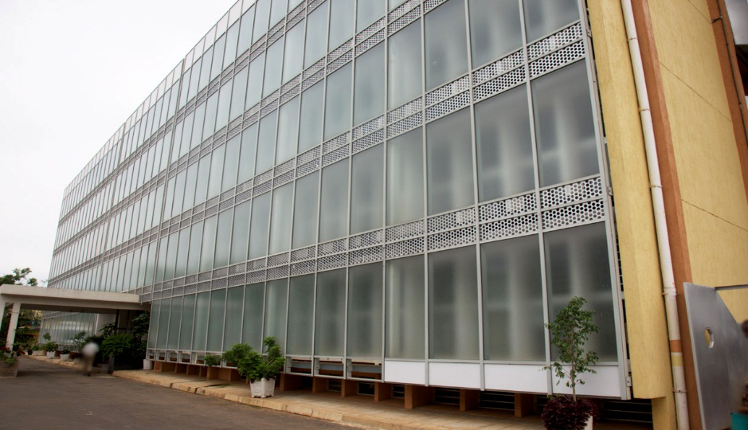

**Figure 1 : RBA profile**

# 2.2. MISSION OF RBA

RBA's mission is to **Inform**, **Educate** and **Entertain** while keeping in mind the best interests of the general Rwandan population, to provide quality content that meets the needs of their audiences and promote cultural values.

# 2.3. OBJECTIVE OF RBA

Objective of RBA is to provide a wide range of information and broadcasts as well as entertainment programs with the aim to promote the Rwandan society and meeting people's needs.To achieve its objective, RBA shall use Radio broadcasting, Television and modern information technology.

# CHAPTER 3: REPORT ON WORK CARRIED OUT

## 3.1. Summary of the attachment activities

During my internship period, I have participated in different activities and tasks in different department or areas for the first time they walked me in different server, control room, and studio, so I’m going through of what I have learnt according to my department and also I have learnt extra things.

### **3.1.1 participation approach**

After observation, documentation and interviewing I had participated in different activities and tasks such as working in RTV Sound as an operator, camera operator (CCU manager) and in the control room of RTV, Installation of RTV OB VAN in the different events.

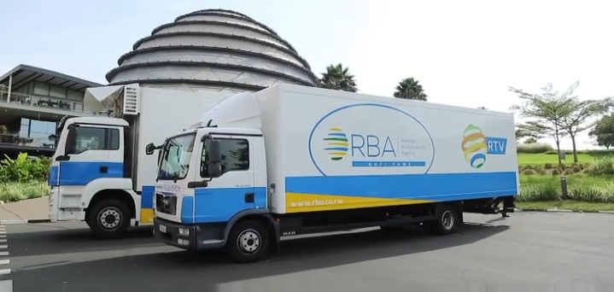

**Figure 2:** **OB VAN**

## 3.2. What I learnt in my department(IT)

### 3.2.1. Networking skills

We have performed different things in networking learnt how to make it in theory and even practices. Those activities are Ozeki,sophosi,teradek,Switch stacking and how to configure switches in in different network.

### a.Introduction to ozeki

Ozeki NG SMS Gateway is a software product that can be installed on your computer. This SMS gateway provides the SMS functionality that is needed to send SMS from your corporate IT system to mobile phones. If you implement this software then it is also possible to use Ozeki SMS Client to send SMS messages. This client functions as an e-mail application on your computer.

Therefore you can compose your message in it and send this composed message to cell phones of predefined recipients.

The figure below shows how when you want to create an SMS looks like in ozeki

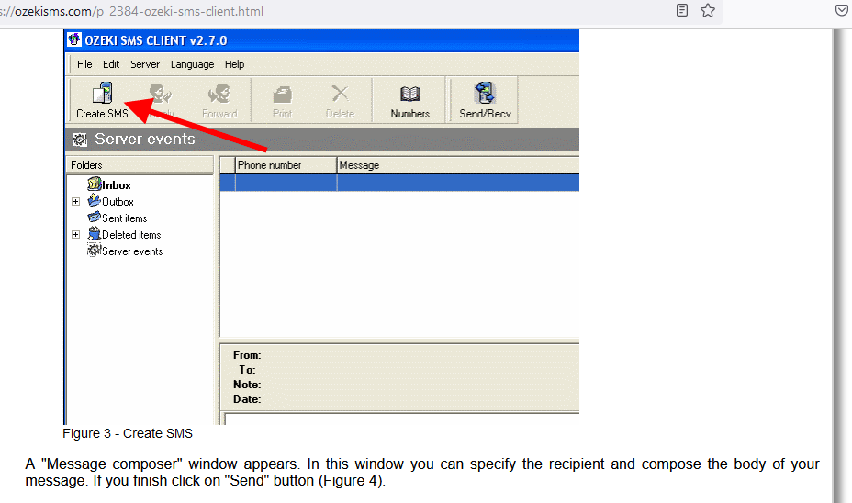

**Figure 3: Ozeki when you want to create an SMS**

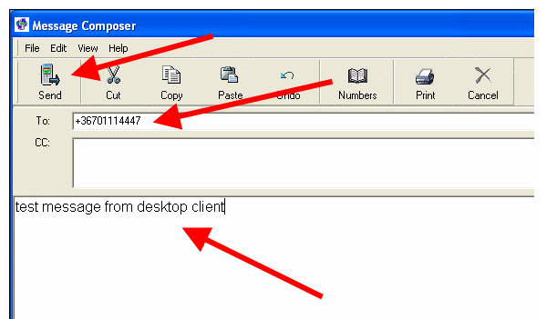

**Figure 4: Ozeki when you to send an SMS to some one**

The messages are sent to the mobile network via Ozeki NG SMS Gateway that forwards messages either with GSM modem connection or IP SMS connection. With this software product you will be able to build a very effective corporate SMS system to improve communication with your customers, partners, suppliers, etc..

We have made different research on how sophosi and teradek works and the showed us how they use it .

### B. Sophosi

Know how does Sophos Firewall Work as it combines **numerous protection features into a single device to provide good network security**. This acts as the gateway of the network and secures it from virus, vulnerabilities in the web applications, malware, and advanced aimed attacks.

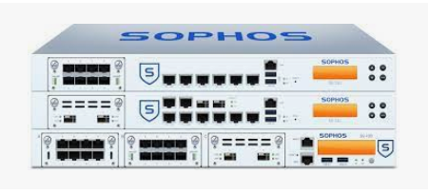

**Figure 5 : This is how SOPHOS looks like**

### C.Teradeck

Teradek is a manufacturer and designer of high-performance video broadcasting solutions for professional television and filmmaking, as well as everyday streaming. Many of the company's wireless video transmitters and receivers broadcast to several channels simultaneously. Option like the Teradek VidiU Pro, for example, allow you to stream video live in high-resolution.

**Figure 6 : Teradek**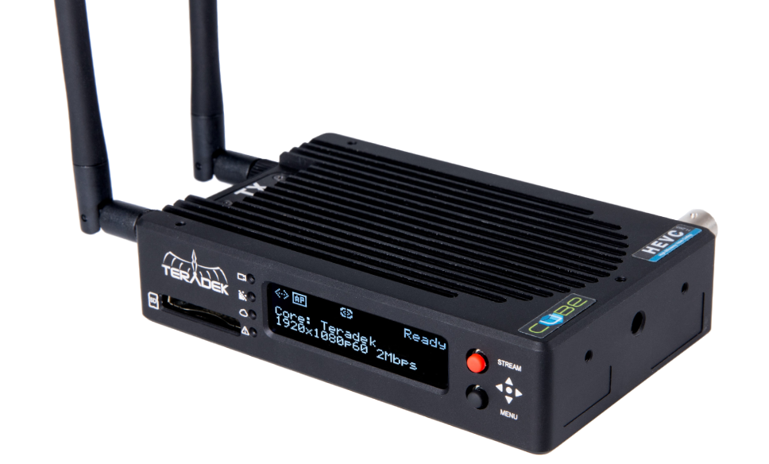

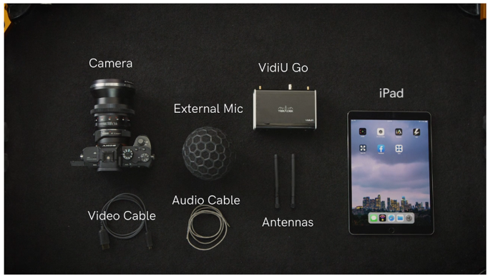

**Figure 7 : Materials for connecting Teradek**

### D. What is the Switch Stacking?

The Switch Stacking is a feature that allows us to configure multiple Cisco switches in a way that they appear as a single switch and act cooperatively. For example, if you have five individual Cisco switches, the Switch Stacking allows you to use all of them as a single large switch.

The following image shows an example of the Switch stacking.

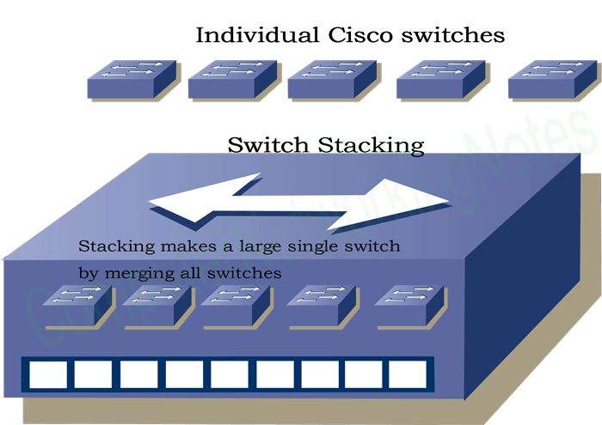

**Figure 8: Switch stacking**

E.**Configuration of switch and Router in different network**

In this period of internship we have performed different things in networking such as topologies for how to configure different switches and router in network like RBA.the following is the one of the topology where we have created 3 router in the network such as TV , Radio,control .

**E. We learnt how to make the following cables**

**i.Ethernet cables(RJ45):** The eight-pin RJ45 connector is a standardised interface which often connects a computer to a local area network (LAN).

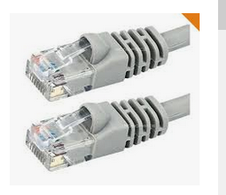

**Figure 9: Ethernet cable**

**ii.SDI: Definition serial digital interface (SDI) :**Serial digital interface (SDI) is a standard for digital video and audio transmission over coaxial or fiber optic cabling. Speeds currently range from 270 megabits per second (Mbps) up to 12 gigabits per second (Gbps) for the latest standard released in 2015.

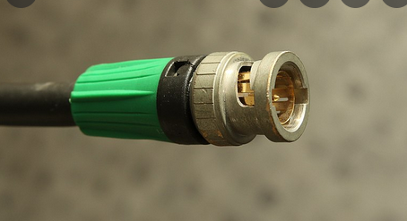

**Figure 10: SDI Cable**

**iii.trialx cable : Triaxial cable**, often referred to as **triax** for short, is a type of electrical cable similar to coaxial cable, but with the addition of an extra layer of insulation and a second

conducting sheath. It provides greater bandwidth and rejection of interference than coax, but is more expensive.

The most common use of triaxial cable is in television industry as a connecting cable between a camera and its camera control unit (CCU).

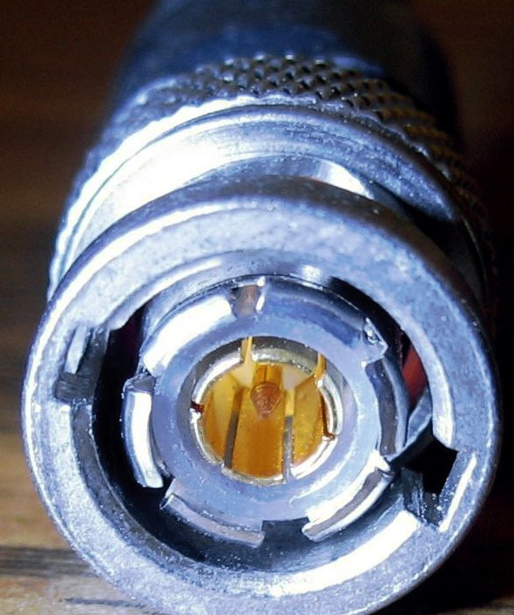

**Figure 11: Triax cable**

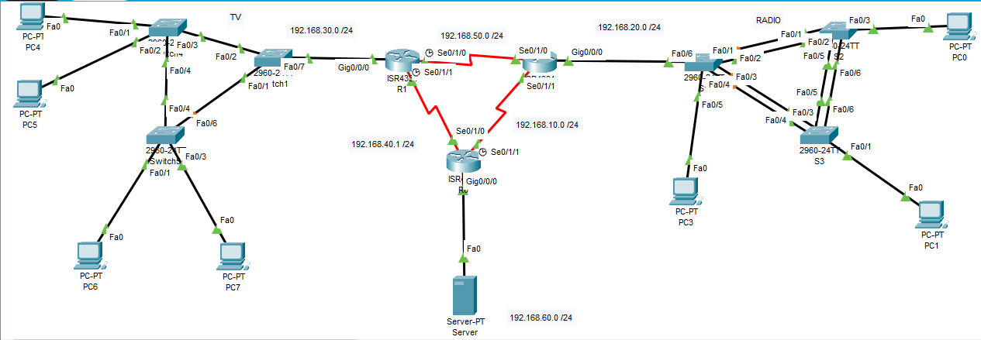

**Figure 12 : Network topology**

On this topology we have configured different command like basic configuration (name router, line vty ,console, , banner modt),we have created vlans,ospf,and also authentications.

### 3.2.2. Maintenance skills

We have installed different operating system like window 10,open suse and also we made troubleshooting for different computers the one of the problem we have solved in looking like this:

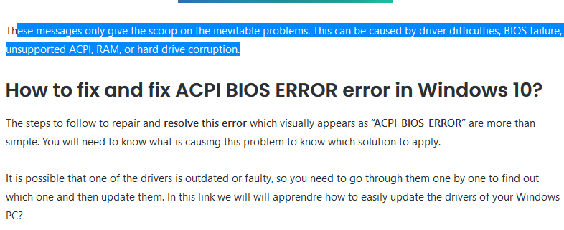

**Figure 13: how to fix Bios Error**

## 3.3. Problems encountered during industrial attachment.

As it was new life, I have experienced different challenges and difficulties in my journey like not getting every practical need to fulfill my curiosity, inability to visit different important areas because of time issue, I have also experienced difficulties in transport as it was required to get there on time.

## 3.4. How to utilize the gained experiences into your future career/ work?

According to what I have learnt in this industrial attachment period I will be able to work in any broadcasting company because I experienced the operations of how broadcasting system work in this internship period. So that when I got opportunity of job in Technical department based on Information and Technology operation I can do it because I have some experience about that .

# CHAPTER4. CONCLUSION AND RECOMMENDATIONS

## 4.1. RECOMMENDATIONS

While we were working on this industrial attachment Report we met with some obstacles and challenges such as Transport problems due corona virus and short time of working because of corona virus. And also we recommend IPRC-TUMBA Staff Especially Information and Technology Department encourage student to visit Rwanda Broadcasting Agency or other broadcasting company because it will help them get some experience in networking course, multimedia, maintained course, installation and configuration different devices and servers, in general and also student That are interested can be attached in broadcasting company as well as RBA.

## 4.2. CONCLUSION

As conclusion therefore, I can conclude that this internship I experienced different things such as sound operation, how to control camera and then how to use it, we have solved different problems for computers and the skills obtain will lead me in my carrier.